**Guia 25: Retrofit**

1. Crear un proyecto base
2. Agregar la libreria de Retrofit (Gradle app) (<http://square.github.io/retrofit/>, gson de google y gson converter.)

apply **plugin**: **'com.android.application'**

android {

compileSdkVersion 25

buildToolsVersion **"26.0.1"**

defaultConfig {

applicationId **"mobile.miempresa.com.retrofit"**

minSdkVersion 14

targetSdkVersion 25

versionCode 1

versionName **"1.0"**

testInstrumentationRunner **"android.support.test.runner.AndroidJUnitRunner"**

}

buildTypes {

release {

minifyEnabled **false**

proguardFiles getDefaultProguardFile(**'proguard-android.txt'**), **'proguard-rules.pro'**

}

}

}

dependencies {

compile fileTree(**dir**: **'libs'**, **include**: [**'*.jar'**])

androidTestCompile(**'com.android.support.test.espresso:espresso-core:2.2.2'**, {

exclude **group**: **'com.android.support'**, **module**: **'support-annotations'**

})

compile **'com.android.support:appcompat-v7:25.3.1'**

compile **'com.android.support.constraint:constraint-layout:1.0.2'**

testCompile **'junit:junit:4.12'**

compile **'com.squareup.retrofit2:retrofit:2.3.0'**

**compile 'com.squareup.retrofit2:converter-gson:2.0.0-beta4'**

**compile group: 'com.google.code.gson', name: 'gson', version: '2.8.2'**

}

3. Ingresar a postman y verificar la estructura de Respuesta del método web service.

<https://openlibrary.org/api/books?jscmd=data&format=json&bibkeys=ISBN:0596154615>

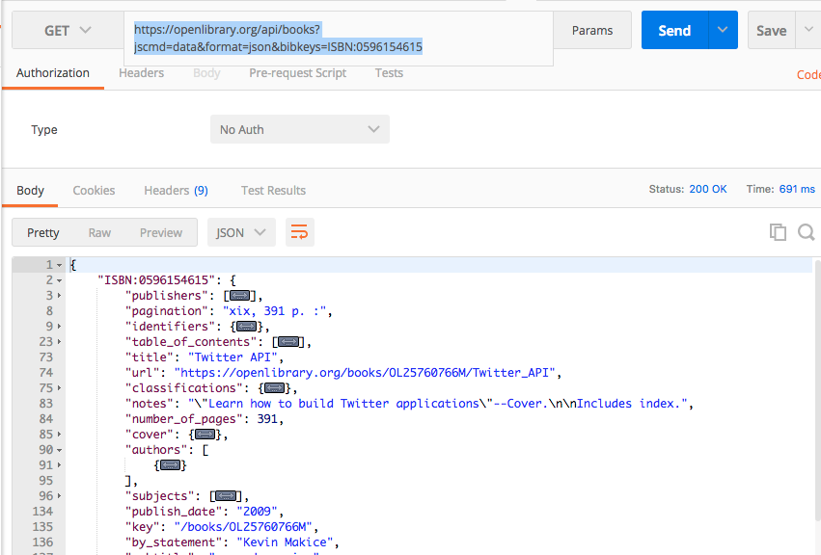

4. Extraer el Nombre del autor, año de publicación, número de páginas y título.

Para ello crear la clase BookResponse.java

**package** mobile.miempresa.com.retrofit;

**public class** BookResponse {

**private** String **isbn**;

**private** String **title**;

**private** String **author**;

**private** String **publish_date**;

**private int number_of_pages**;

**public** BookResponse(String isbn, String title, String author, String publish_date, **int** number_of_pages) {

**this**.**isbn** = isbn;

**this**.**title** = title;

**this**.**author** = author;

**this**.**publish_date** = publish_date;

**this**.**number_of_pages** = number_of_pages;

}

**public** String getIsbn() {

**return isbn**;

}

**public void** setIsbn(String isbn) {

**this**.**isbn** = isbn;

}

**public** String getTitle() {

**return title**;

}

**public void** setTitle(String title) {

**this**.**title** = title;

}

**public** String getAuthor() {

**return author**;

}

**public void** setAuthor(String author) {

**this**.**author** = author;

}

**public** String getPublish_date() {

**return publish_date**;

}

**public void** setPublish_date(String publish_date) {

**this**.**publish_date** = publish_date;

}

**public int** getNumber_of_pages() {

**return number_of_pages**;

}

**public void** setNumber_of_pages(**int** number_of_pages) {

**this**.**number_of_pages** = number_of_pages;

}

}

5. Crear la clase ConstantsRestApi.java

**package** mobile.miempresa.com.retrofit;

**public class** ConstantRestApi {

**public static final** String ***VERSION*** = **"/api/";**

**public static final** String ***URL*** = **"https://openlibrary.org"**;

**public static final** String ***URL_BASE*** = ***URL***+***VERSION***;

**public static final** String ***URL_BOOK*** = **"books?jscmd=data&format=json&bibkeys=ISBN:"**;

}

6. Crear la interface EndPointApi.java

**import** retrofit2.Call;

**import** retrofit2.http.GET;

**import** retrofit2.http.Path;

**public interface** EndPointApi {

*//?jscmd=data&format=json&bibkeys=ISBN:*

@GET(ConstantsRestApi.***URL_BOOK***)

Call<BookResponse> getList(@Query(**"jscmd"**) String jscmd, @Query(**"format"**) String format, @Query(**"bibkeys"**) String bibkeys );

}

7. Crear la clase RestApiAdapter.java

**import** com.google.gson.Gson;

**import** com.google.gson.GsonBuilder;

**import** retrofit2.Retrofit;

**import** retrofit2.converter.gson.GsonConverterFactory;

*/\*\**

*\* Created by robertocarloscallisaya on 10/10/17.*

*\*/*

**public class** RestApiAdapter {

*/\*\**

*\* Get connexion rest api generic with param gson converter target objet*

*\**

*\** ***@param gson***

*\** ***@return*** *EndPointApi*

*\*/*

**public** EndPointApi connexionApi(Gson gson) {

Retrofit retrofit = **new** Retrofit.Builder()

.baseUrl(ConstantsRestApi.***URL_BASE***)

.addConverterFactory(GsonConverterFactory.*create*(gson))

.build();

**return** retrofit.create(EndPointApi.**class**);

}

**public** Gson buildGsonDeserializedBook(String isbn) {

GsonBuilder gsonBuilder = **new** GsonBuilder();

gsonBuilder.registerTypeAdapter(BookResponse.**class**, **new** BookDeserialized(isbn));

**return** gsonBuilder.create();

}

}

8. Crear la Clase BookDeserialized.java

**import** com.google.gson.Gson;

**import** com.google.gson.JsonDeserializationContext;

**import** com.google.gson.JsonDeserializer;

**import** com.google.gson.JsonElement;

**import** com.google.gson.JsonObject;

**import** com.google.gson.JsonParseException;

**import** java.lang.reflect.Type;

*/\*\**

*\* Created by robertocarloscallisaya on 10/10/17.*

*\*/*

**public class** BookDeserialized **implements** JsonDeserializer<BookResponse> {

**private** String **isbn**;

**public** BookDeserialized(String isbn) {

**this**.**isbn** = isbn;

}

@Override

**public** BookResponse deserialize(JsonElement json, Type typeOfT, JsonDeserializationContext context) **throws** JsonParseException {

System.***out***.println(**new** Gson().toJson(json.getAsJsonObject()));

JsonObject jsonObject = json.getAsJsonObject().get(**"ISBN:"**+**this**.**isbn**).getAsJsonObject();

BookResponse resp = **new** BookResponse(**"123456"**,jsonObject.get(ConstantsRestApi.***BOOK_TITLE***).getAsString() , **"Autor"** ,**"2017"**, 150);

**return** resp;

}

}

9. Modificar el archivo Android Manifest y agregar el permiso de Internet.

<**uses-permission android:name="android.permission.INTERNET"**/>

10. Modificar el archivo MainActivity.java para llamar al metodo de la api.

**import** android.support.v7.app.AppCompatActivity;

**import** android.os.Bundle;

**import** com.google.gson.Gson;

**import** retrofit2.Call;

**import** retrofit2.Callback;

**import** retrofit2.Response;

**public class** MainActivity **extends** AppCompatActivity {

@Override

**protected void** onCreate(Bundle savedInstanceState) {

**super**.onCreate(savedInstanceState);

setContentView(R.layout.***activity_main***);

String isbn = **"0596154615"**;

RestApiAdapter restApiAdapter = **new** RestApiAdapter();

EndPointApi endPointApi = restApiAdapter.connexionApi(restApiAdapter.buildGsonDeserializedBook(isbn));

Call<BookResponse> bookResponseCall = endPointApi.getList(**"data"**, **"json"**,**"ISBN:"**+isbn);

bookResponseCall.enqueue(**new** Callback<BookResponse>() {

@Override

**public void** onResponse(Call<BookResponse> call, Response<BookResponse> response) {

BookResponse book = response.body();

System.***out***.println( **new** Gson().toJson(book));

}

@Override

**public void** onFailure(Call<BookResponse> call, Throwable t) {

System.***out***.println(**"Ocurrio un error"** + t.getLocalizedMessage());

}

});

}

}